SOFT SKILL 1: MODULE 3: CONFIDENCE
Aptitude Test
NAME: Harsh Talreja

Logical Reasoning:
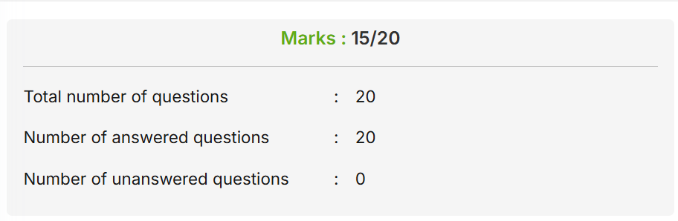
Non-Verbal Reasoning
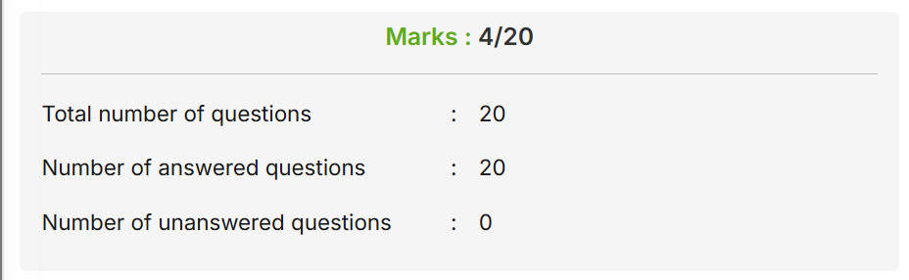

Data Interpretation:
